

AUGUST 2013

PRESIDENT’S MESSAGE

Cari amici,

I recently set a goal of increasing our IHL membership by ten percent by the end of this year. I am pleased to advise you that our lodge has received ten new membership applications since April. That increases our membership to around 100, including social members, and it achieves our goal! I want to thank you for your efforts in talking up our organization with your friends, neighbors and relatives. This has helped to reverse a downward trend in membership over the last few years. But let’s not rest on our laurels. I encourage you to continue your efforts to solicit new members by talking about the events we sponsor and about our efforts to support charitable causes that benefit our community. Let’s press our goal and see if we can get another ten new members by the end of this year!

Our participation in the Fairfax City Fourth of July Parade was a tremendous success thanks in great part to the organizing efforts of Joe La Marca. If you participated in the lodge parade unit this year, I sincerely hope you enjoyed it. If you didn’t join the parade, please put it on your calendar for next July 4th. The weather was kinder to us this time, and we obtained some good publicity for our lodge. At least two objective measures confirm this: one viewer of the parade on TV became aware of us for the first time and joined the lodge; and, we were one of only three units selected this year as best in the category, “Marching Unit – Adult.” (OK, “Third Place,” but still in the top three!). If you have any suggestions for improvements for our unit’s performance next year, please let us know. Meanwhile, if you were there and took any photos, please send them to Joe La Marca for posting on the lodge web site and perhaps in the Grand Lodge newsletter. Our thanks go also to Laura and John Asiello for hosting an after the parade cookout for all of the IHL participants and their friends.

Our Sunday, July 14^{th,} annual IHL picnic drew around fifty members and guests. This was down from last year partly due to the hot weather. The IHL Council is considering moving this event to the spring or fall next year in an attempt to make it more comfortable for our members.

If you haven’t done so already, be sure to sign up for our Sunday, August 11th, peach picking outing followed by a lunch at the Blackthorne Inn. Just let Gene La Colla know if you are planning to attend. Details for this event are contained elsewhere in this newsletter.

We will have a casino night on September 14th, 2013, so be sure to solicit gift certificates from your favorite restaurants or bring other items to be given out as prizes at that event. Details regarding this event are also contained in this newsletter.

I continue to be impressed by the generosity of our members by the time they donate and the effort they put forth to help make our events successful and fun for all.

A Presto,

Dennis

ITALIAN HERITAGE LODGE 2517 – OFFICERS

President Dennis Lillo Lodge Trustees
703 354 2454 Delillo1(at)Verizon.Net Kevin Brady----Lucio D’Andrea
Vice-President Sal Guli Jo Lowe----Victor Haburchak
703 321 9552 Salguli(at)Cox.Net Fred Michaelangelo
Imm Past-President Anne Marrelli Master/Mistress of Ceremonies
703 385 0814 Anne.Marrelli(at)gmail.com Paul Alligood
Orator Dot Saia Rosalie Ciccotelli
703 978 8499 Dmjcs(at)Cox.Net Sentinel ---- Bruno Diconi
Recording Secy Eleanor Lillo Membership Chair:
703 354 2454 Delillo1(at)Verizon.Net John Asiello (jfasiello(at)AOL.Com)
Financial Secy Laura Strong 703 321 7840
703 942 6323 Laura.Strong(at)us.army.mil Education Chair:
Treasurer Gene La Colla Art Moscatello (ArthurMoscatello(at)
703 246 9464 Gino4one(at)AOL.Com Comcast.Net)
Publicity Chair: Joe La Marca Member on the Grand Lodge:
(Jlamarca(at)erols.com John Asiello, Trustee
703 455 0376

La Bandiera Editor:

Paul Alligood, 703 848 1758 – Palli14145@AOL.Com, 1908 Youngblood St., McLean, Va. 22101

Visit our lodge website at WWW.ITALIANHERITAGELODGE.ORG. Check the website for breaking news between newsletter editions.

SAVE THE DATES - FUTURE LODGE EVENTS

Aug 11 Peach Picking & Lunch 10:30 AM Perfection Orchard &
Blackthorn Restaurant

Aug 14 Lunch Bunch 12:00 Noon Olive Garden-Falls Church

Aug 24 Language Group 6:00 PM At the Alligood’s

Sept. 14 Lodge Meeting (Casino Night) 6:30 PM At K of C

Sept. 18 Council Meeting 7:00 At Fairfax Library

Oct. 12 Lodge Meeting (Dancing) 6:30 PM At K of C



LODGE ANNOUNCEMENTS

New photos are now available on the web site starting with Casino Night in 2012 and ending with the June, 2013 lunch bunch. Anyone who has photos of the 2013 parade, picnic and lunch bunch, please send them to Joe La Marca at jlamarca@erols.com

AUGUST BIRTHDAYS

Joyce Taormina Aug. 9 Dennis Lillo Aug. 25
Renee Signorelli Aug. 12 Eleanor Lillo Aug. 28
Henry Colletto Aug. 17 Antonella Reed Aug. 28
Bob Maida Aug. 19 Anne Marrelli Aug. 29
Russell DeRose Aug. 20


AUGUST ANNIVERSARIES

Edward & Linda Majca Aug. 3
Vincent & Karen Serafino Aug. 10
Frank & Dolores Marcinkowski Aug. 13
Carlo & Betsy Mignani Aug. 22

PREVIEW OF COMING ATTRACTIONS

August 11 – peach picking at Perfection Orchard and lunch at the Blackthorne Inn. If it rains, go directly to the Blackthorne.

Sept. 14 – Lodge meeting at K of C hall behind St. Leo’s Church. Program is casino night.

Oct. 12 – Ballroom Dancing at K of C. Details in a future newsletter.

AUGUST LUNCH BUNCH

The Lunch Bunch will meet on Wednesday, August 14th, at noon at the Olive Garden Restaurant located at 3548-52 South Jefferson St., Falls Church, VA 22041. Tel: 703 671 7507. It is located across from the Skyline Mall on Route 7. They have a soup and salad special that is very popular. They also have a special 2 for 1 promotion at $25 that looks like a good deal in addition to their regular entrees. Please let Dennis Lillo know if you plan on attending so he can make the appropriate reservation. Email at delillo1@verizon.net or call at 703-354-2454.


orm
Bottom of Form

PEACH PICKING AND LUNCH AUGUST 11th

IN LIEU OF OUR AUGUST GENERAL MEMBERSHIP MEETING,
THE LODGE IS SPONSORING AN OUTING ON AUGUST 11TH TO
VIRGINIA PERFECTION ORCHARD AND LUNCH AT THE BLACKTHORNE
RESTAURANT. HERE ARE THE DETAILS:

PEACH PICKING AT VIRGINIA PERFECTION ORCHARD IS $12 a
PECK. THEY HAVE 3 VARIETIES OF PEACHES.

FOR THOSE WHO WISH TO CAR POOL, WE WILL MEET AT THE
COURTHOUSE SHOPPING CENTER JUST BEFORE THE NEW LIBRARY
ON OLD LEE HIGHWAY WEST OF ST. LEO’S CHURCH AT 10:30 AM.

FOR RESERVATIONS CONTACT GENE LA COLLA
BEFORE AUGUST 9TH.
703 246 9464 gino4one@aol.com

DIRECTIONS TO VIRGINIA PERFECTION ORCHARD
1562 LEEDS MANOR ROAD, DELAPLANE, VA 20144

I-66W TOWARD FRONT ROYAL - 36 MILES
TAKE EXIT 23, US-17 N TOWARD DELAPLANE - 6 MILES
TURN LEFT ON LEEDS MANOR RD. - ½ MILE.
ORCHARD IS ON THE RIGHT. 540 592 3730

DIRECTIONS TO BLACKTHORNE RESTAURANT
LUNCH AT 1 PM

START OUT BY GOING NORTHEAST ON LEEDS MANOR RD.
TOWARD WINCHESTER RD. US-17 - ½ MILE
TURN LEFT ON WINCHESTER RD. US-17 - 2 MILES
TURN RIGHT ON JOHN MOSBY HIGHWAY US-50 EAST - 1 ½MILE.
RESTAURANT IS ON THE RIGHT. 540 592 3848

CASINO NIGHT: September 14, 2013
The September lodge meeting will feature a “Casino” evening. To be successful, the following are required:
1. PLAY AND INVITE OTHERS TO PLAY: We need full participation by our membership for this Charitable Fund Raising event. The more that play, the greater the -un and the greater the Funds collected for Charity. We will be collecting $5.00 in real money from each individual in exchange for $25.00 in play money to bankroll gaming for the evening. You may buy as much play money as you desire. I know that all our dealers will be very customer-friendly, and you will have a great time so don’t miss it. . You may want to invite friends or potential members to this fun event which will help to increase our financial success. At the conclusion of the games, winners, in the order of their winnings, will bid on the prizes.
2. GET GIFT CERTIFICATES: We hope to have some of our favorite restaurants donate dinner prizes; however, we ask that each lodge member bring a special item that you can donate to provide a prize upon which our winners can bid. Also, I have included a two page information sheet that can be used by you to contact your store or restaurant that you patronize to seek a gift certificate for the event. PLEASE PRINT AS MANY AS YOU CAN USE.
3. BRING FINGER FOOD TO SHARE: Finally, we will start and continue the evening with finger food snacks and beverages so that people can munch as they move around the gaming tables. A celebrity waitress will be available for food and beverage service so no need to leave the gaming tables.
“DON’T MISS THIS FUN FILLED EVENING – BRING FRIENDS AND RELATIVES TO THIS FUND RAISER FOR COOLEY’S ANEMIA, ALZHEIMER’S, AUTISM AND LOCAL SCHOLARSHIPS”

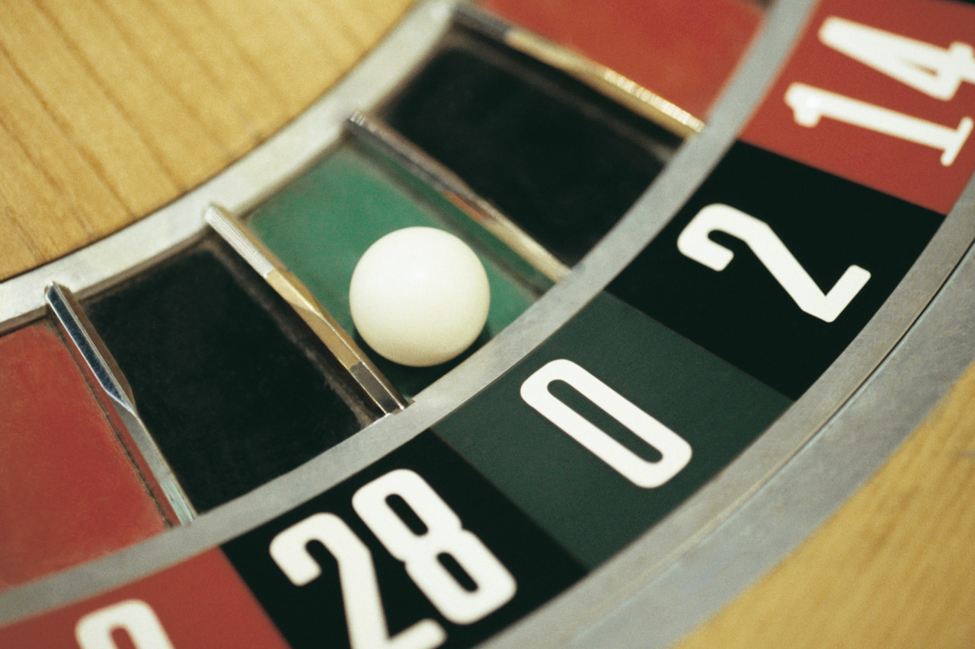


Italian Heritage Lodge #2517
Order Sons of Italy in America
Fairfax County, Virginia

July 18, 2013

John F. Asiello Jr., Chairman
Italian Heritage Lodge - Special Events
5306 Inverchapel Road
Springfield, Virginia 22150

Subject: Request for Gift Certificate

Dear Management,

On behalf of the officers and members of the Italian Heritage Lodge #2517 Order Sons of Italy in America, we would like to request your support to our fundraising event for charity.

Our annual “Casino Night” fundraising event this year will be held on September 14, 2013. Last year the event was a huge success, and we gave out “Gift Certificates” from restaurants and establishments as prizes which helped this to be a major financially rewarding charitable venture.

Our targeted charities for this year are Alzheimer’s disease, Cooley’s anemia, Autism and Local Scholarships. It will be rewarding for you to know that 100% of all moneys collected will go directly to these charities.

Support from our sponsors is the major reason for our organization’s financial ability to give generously to these charities and our members have been asked to patronize our sponsors, both verbally and in our published Newsletter, “La Bandiera.”

We hope that you will provide a “Gift Certificate” in support of our charities. One of our members will be contacting you soon should you desire to participate this year.

We thank you in advance for your generosity,

John F. Asiello Jr.
Chairman, Special Events
(703 321-7840)

CHARITY EVENT:

Sponsored by the

Italian Heritage Lodge #2517

Enjoy yourself at our next fun time

“CASINO NIGHT”

Saturday September 14, 2013

Join us and have a great time playing our variation of CASINO games: Stud Poker, Over & Under, Black Jack, Beat the Dealer and more.

REMEMBER WE USE “PLAY MONEY” AND WINNERS GET GIFTS donated by members and local businesses.

This is a “Finger food event” fare, so bring your favorite hors d’oeuvres, finger food, crackers, cheese bits and desserts.
The Lodge will have wine, soda, beer, coffee, hot chocolate, etc.

Where: K of C Hall adjacent to St Leo’s Church on Old Lee Highway in Fairfax.

Time: 6:30 PM - Games will start as soon as guests are ready
and then the real Fun begins.

Admission: $5.00 donation for $25 in Play Money (Purchase more as desired)

Charities: Proceeds support our charities such as Alzheimer’s, Cooley’s anemia, Autism and Local Scholarships Programs.

PLEASE COME AND BRING A FRIEND

ITALIAN WORDS AND PHRASES

L'acqua alta di Venezia

Con l’arrivo delle piogge, si assiste puntualmente al fenomeno dell’acqua alta. Ogni volta che la pioggia cade in abbondanti quantità, cittadini e turisti si trovano a dover fare i conti con il fatto che la maggioranza della città è invasa dall’acqua. L’acqua è considerata alta quando supera i 90 cm. (35.4 pollici) sul livello del mare.

La peggiore inondazione si ebbe nel 1966, quando l’acqua raggiunse i due metri, (79 pollici) causando gravissimi danni.

L’acqua alta arriva regolarmente nella città di Venezia soprattutto durante le alte maree tardo-autunnali e primaverili. Sommerge le strade più basse di Venezia ma, nei casi più gravi, fino al 96% delle vie cittadine, minacciando ogni volta i circa 60.000 residenti e le migliaia di turisti che la visitano ogni anno. Quindi a meno che non ti piaccia proprio camminare nell'acqua quello non è il migliore periodo per visitarla.

Venice's high water

With the arrival of the rains, you can experience the recurring phenomenon of high water. Every time the rain falls in abundant quantities, citizens and tourists find themselves having to deal with the fact that the majority of the city will be invaded by water. The water is considered "high" when it exceeds 90 cm (35.4 inches) above sea level.

The worst flooding took place in 1966, when the water reached a height of two meters, (79 inches) causing serious damage.

High water arrives regularly in the city of Venice especially during late-autumn and spring high tides. It submerges the lower streets of Venice but, in the worst cases, up to 96% of the city's streets, threatening each time the nearly 60,000 residents and the thousands of tourists who visit it every year. So, unless you really like to walk in the water, maybe that is not the best time to visit.

From Carlo & Betsy Mignani

2013 JULY 4 PARADE
Twenty-five IHL members and guests participated in this year’s Fourth of July Parade. It was an enjoyable day as the weather was not too severe. If you didn’t join the parade this year be sure to put it on your calendar for next July 4th as we still need more of our friends, neighbors, and colleagues to join us next time. We also obtained some good publicity for our lodge as one viewer of the parade on TV became aware of us for the first time and joined the lodge; and, according to http://www.fairfaxva.gov/specialevents/IDC/Awards.asp , we were one of only three units selected this year as best in the category, “Marching Unit – Adult.” (OK, “Third Place,” but still in the top three!). If you have any suggestions for improvements for our unit’s performance next year, please let us know. Meanwhile, if you were there and took any photos, please send them to Joe LaMarca for posting on the lodge web site and perhaps in the Grand Lodge newsletter.



