

JUNE 2012

PRESIDENT’S MESSAGE

Cari amici,

This month we celebrate our fathers, the men who demonstrated their great love for us each day with their hard work, support, discipline, and courage in dealing with the complexities of life. Happy Father’s Day to all our lodge fathers and grandfathers! We also celebrate the graduations from high school and college of our children and grandchildren who are moving on to new life adventures. We wish them the best.

Our lodge meeting this month is Saturday, June 2. Please join us for an enjoyable evening. The program details will be provided in an e-mail a few days before the meeting.

In May, several of us honored our Italian heritage by attending the stirring opera, Nabucco, by Giuseppe Verdi at the Kennedy Center. The excellent orchestra and staging provided an exciting context for the talented singers who brought to life the story of the Babylonian king, Nebuchadnezzar (known as Nabucco) and the persecution of the Jewish people. The director added to the original Verdi opera the device of staging an opera within an opera. Nabucco began with men and women in fancy evening dress of Verdi’s time gracefully dancing and then sitting in opera boxes on the side of the stage to watch the opera. They also danced between each act. Austrian soldiers marched in formation across the stage at the beginning of the performance and between acts. This device emphasized that Verdi’s opera was a lightly veiled protest of the Austrian tyranny of Italy at the time. At the close of the opera, the much loved chorus, “Va, pensiero”, was sung by the entire cast amid displays of green, white, and red banners. It was a thrilling conclusion to a lovely evening.

We have several exciting events coming up this summer including a bocce tournament, the Fairfax Independence Day parade, a trip to Wolf Trap to hear a recital of songs by Italians and Italian-Americans, our annual picnic, and peach picking as well as the very popular monthly lunches. Please see the information in the newsletter about all these opportunities to have fun and socialize with your lodge brothers and sisters.

A presto,

Anne

ITALIAN HERITAGE LODGE 2517 – OFFICERS

President Anne Marrelli Lodge Trustees
703 385 0814 Anne.Marrelli(at)gmail.com Sal Guli----Angelo Vecchio
Vice-President Fred Michaelangelo Tony Finocchiaro----Dennis Lillo
703 323 8294 AMichaelangelo(at)msn.com Art Moscatello
Imm Past-President Frank Marcinkowski Master/Mistress of Ceremonies
703 323 8447 FMarcinkow(at)Verizon.Net Kevin Brady
Orator Dot Saia Yolanda Pelosi
703 978 8499 Dmjcs(at)cox.net Sentinel ---- Paul Alligood
Recording Secy Eleanor Lillo Membership Chair:
703 354 2454 Delillo1(at)Verizon.Net John Asiello (jfasiello(at)AOL.Com)
Financial Secy Jo Lowe 703 321 7840
Lowejs(at)AOL.Com Education Chair:
Treasurer Gene La Colla Art Moscatello (ArthurMoscatello(at)
703 246 9464 Gino4one(at)AOL.Com Comcast.Net)
Members on the Grand Lodge Publicity Chair: Joe La Marca
Susan Agosta McFetridge – Trustee (Jlamarca(at)erols.com)
(smcfetridge(at)caci.com) 703 455 0376

La Bandiera Editor:

Paul Alligood, 703 848 1758 – Palli14145@AOL.Com, 1908 Youngblood St., McLean, Va. 22101

Visit our lodge website at WWW.ITALIANHERITAGELODGE.ORG. Check the website for breaking news between newsletter editions.

FUTURE LODGE EVENTS

June 2 Lodge Meeting 6:30 PM St. Leo’s K of C

June 20 Council Meeting 7:00 PM Fairfax Library

June 23 Language Group 6:00 PM At the Alligoods

TBD Lunch Bunch 12:00 Noon PM Location TBD

July 4 Fairfax Parade 10:00 Fairfax City

July 22 Lodge Picnic 1:00 to 5:00 At St. Leo’s K of C

THIS MONTH’S LODGE MEETING IS ON JUNE 2

The lodge will hold its June general membership meeting on June 2 at St. Leo’s Knights of Columbus hall. The program has not been nailed down at this time but will be communicated in an e-mail prior to the meeting. The dinner will be pot luck with the lodge providing beverages for sale. Hope to see you there.


LODGE ANNOUNCEMENTS

The lodge wishes to extend its sympathy to Dennis Lillo and his family on the death of Dennis’s mother, Ida.

The language group will meet June 23 at 6:00 PM at the home of Rosalie and Paul Alligood, 1908 Youngblood St., McLean, VA 22101. Please inform Carlo and Betsy what dish you plan to provide (mignani(at)cox.net). All lodge members are welcome.

All lodge participants in the July 4 Fairfax parade are invited to attend a picnic immediately after the parade. Details will be available at the parade.

JUNE BIRTHDAYS


Julie DiCerbo June 21
Omero Sabatini June 26

JUNE ANNIVERSARIES

Russell & Karen Marie DeRose June 5 Jason & Tracey Bartolomei June 22
Pat & Janet DiTanna June 8 Salvatore & Diana Guli June 22
Fred & Maria Ingham June 9 Lucio & Edvige D’Andrea June 27
Gregory & Carla Walsh June 9 Joe & Dot Saia June 28

Let’s parade our pride!

Got that red, , green, and/or blue outfit ready for the Fairfax City Independence Day parade, Wednesday morning, July 4? It will be un evento davvero divertente (a really fun event)! Some details are still pending, but our lodge’s six years experience as a parade unit tells us it’s not an event to miss. If you need to ride rather than stroll the mile, a large truck will be available compliments of R.E. Lee Electric Company. The next newsletter will contain all the details about the free parking places, meeting place, and exactly what we will be doing to show our pride. Be sure to invite all your family, friends, and neighbors to participate, as well. If you have any questions, contact our publicity chairman at joe.lamarca@italianheritagelodge.org or phone 703-475-6962.

ITALIAN SONGS AT WOLF TRAP

WHEN: Sunday, July 15, 2012
WHERE: The Barns at Wolf Trap
TIME: 3:00 PM
COST: $32 plus any surcharge
Seats are limited: there are only a few left. First come first served.
I will order by credit card, but your commitment must be final.
Notify me ASAP at delillo1@verizon.net or call at 703-354-2454.
Dennis Lillo

ITALIAN HERITAGE LODGE BOCCE POT LUCK PICNIC!


DATE: Tuesday, June 19th (Rain Date Thursday, June 21st)

TIME: 11:00 AM to 3:00 PM

PLACE: 5104 Colebrook Place, Alexandria VA 22312

RSVP to Dennis Lillo at email delillo1@verizon.net or tel: 703-354-2454. Come and join in on the fun with other lodge members. We expect approximately 25-30 attendees so bring a dish to share with your fellow bocce enthusiasts. All-you-can-drink wine and soft drinks will be available for purchase at $1.00 for soft drinks and $2.00 for wine. We will also hold a 50-50 raffle.







At our May lodge meeting, we talked about publishing the family recipes for the dishes people brought to the meeting. The following recipe was provided by Anne Marrelli. Please send your recipes to palli14145@aol.com so they can be included in future editions of this newsletter.

Mamma Josephine’s Spaghetti al Forno

Recipe of Josephine Teresi Marrelli who learned it from her mother, Frances DeCarlo of northwestern Sicily. Serves 8.

Ingredients:
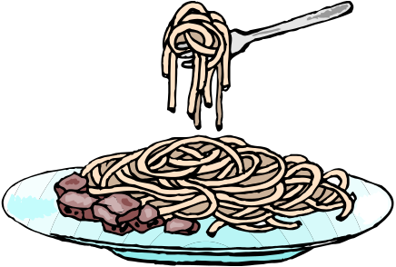
Olive oil
1 large onion, chopped
5 cloves garlic, minced
5 28 oz. cans of tomato puree (without salt)
4 T. dried oregano
6 T. dried basil
6 T. parsley
6 T brown sugar
8 bay leaves
Salt to taste
6 hard-boiled eggs, shelled and sliced

Cook onions and garlic in olive oil in large pot for about 10 minutes. Add remaining ingredients and stir well. Bring to a gentle simmer. Let simmer for 3 hours, stirring at least every 20 minutes. Taste the sauce as it cooks and add salt, spices, and sugar as needed.

Boil 2 pounds of spaghetti until al dente firmness. Combine sauce and cooked spaghetti. Pour half the spaghetti in a large baking pan. Place a layer of eggs on the spaghetti then pour the remaining spaghetti in the pan. Bake in the oven at 350 degrees for about 30 minutes. Cut into squares to serve.

Italian Heritage Lodge representatives Lucio D'Andrea and Arthur Moscatello presented our $500 donation to Mantua Elementary faculty to help support the school's Italian language classes.

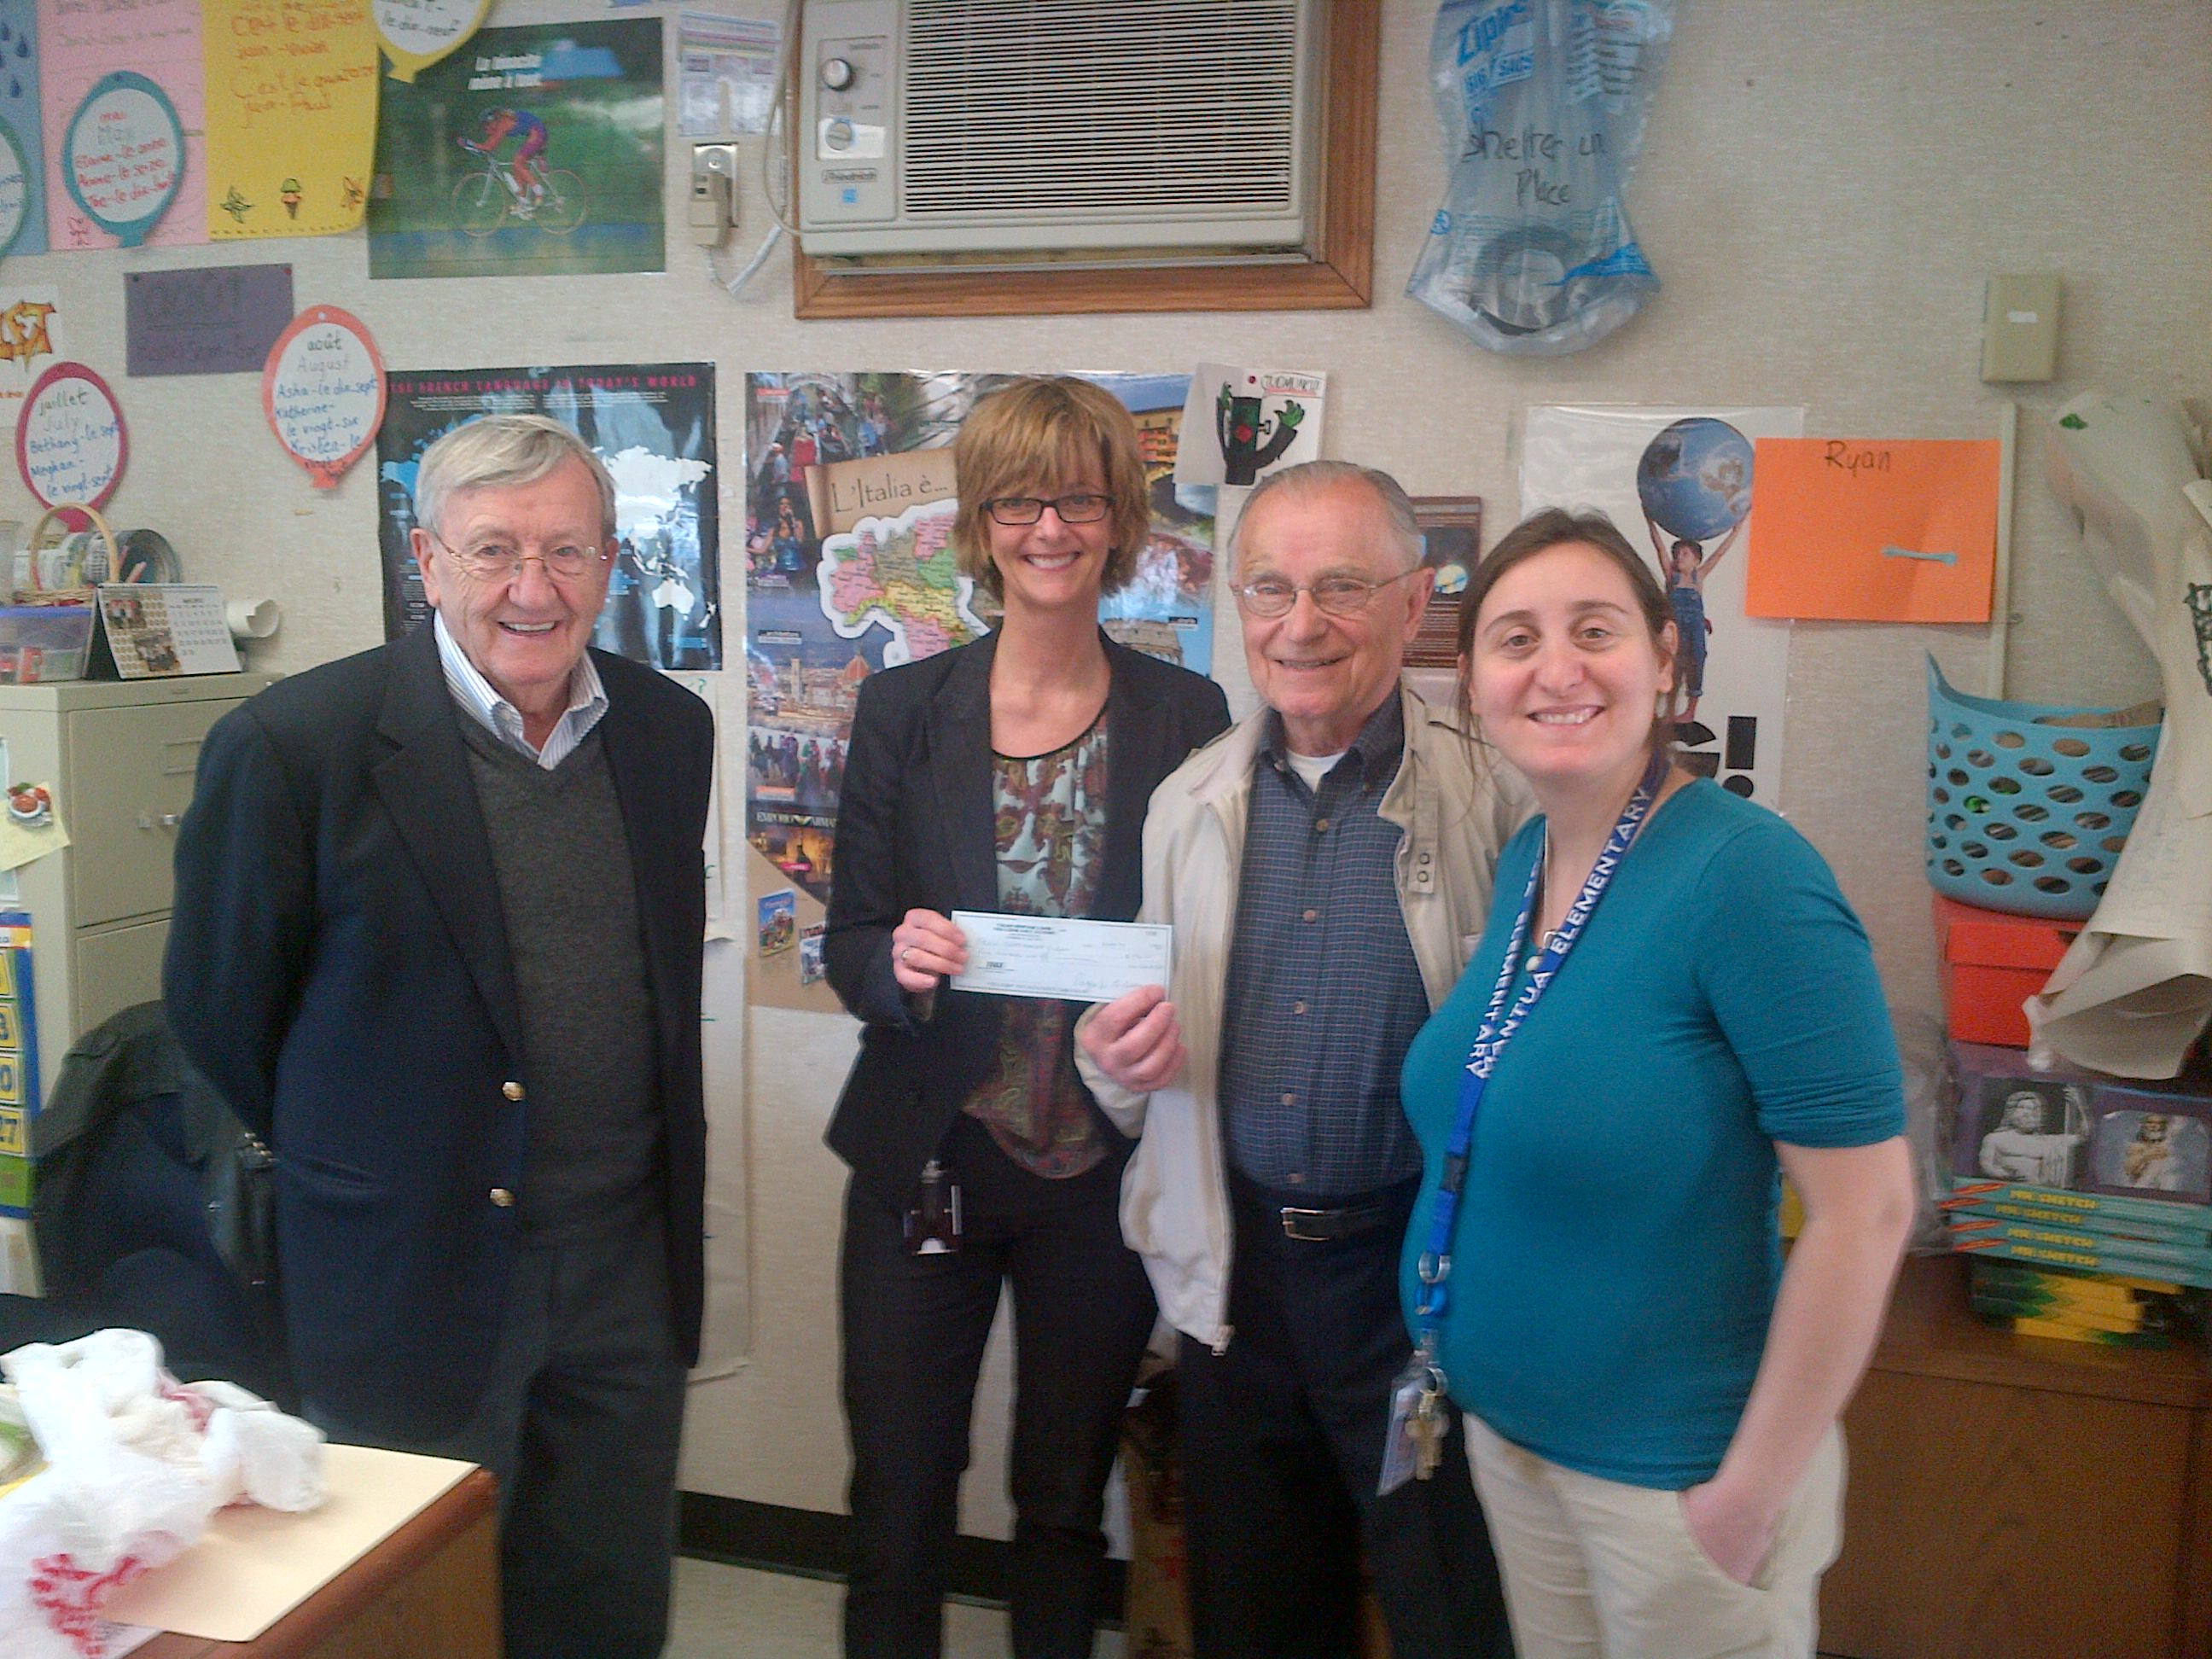

ITALIAN WORDS AND PHRASES
From: Betsy Mignani

Artemisia Gentileschi

Nasce a Roma l'8 luglio 1593, primogenita (eldest child) del pittore Orazio Gentileschi, esponente (exponent) del caravaggismo romano (the Roman Caravaggio style). Presso la bottega paterna (at her father’s studio), assieme ai fratelli (together with her brothers), ma dimostrando rispetto ad essi un ben più elevato talento (but showing a much higher talent), Artemisia ha il suo apprendistato (apprenticeship) artistico, imparando il disegno (drawing), il modo di impastare i colori (mixing colors) e di dar lucentezza (brilliance) ai dipinti. Poiché lo stile del padre, in quegli anni, si riferisce (relates to) esplicitamente all'arte del Caravaggio (con cui Orazio ha rapporti di familiarità), anche gli esordi artistici (early works) di Artemisia si collocano nella scia (are positioned in the wake) del grande pittore lombardo.

Trasferitasi a Firenze nel 1614, ha grande successo. Viene accettata nell'Accademia del Disegno (fu la prima donna a godere di tale privilegio) (she was the first woman to have that privilege); dimostra di saper tenere buoni rapporti con i più reputati artisti (artists of the best reputation) del tempo, e di saper conquistare i favori e la protezione di persone influenti, a cominciare dal Granduca Cosimo II de' Medici e, in special modo della granduchessa Cristina. È in buoni rapporti con Galileo Galilei, con il quale rimane in contatti epistolare (correspondence) ben oltre (well beyond) il suo periodo fiorentino. Dopo, vive a Roma, a Venezia, a Napoli e perfino a Londra dove assiste il padre col l'importante incarico della decorazione di un soffitto per il re.

Artemisia è una artista che lotta con determinazione, utilizzando le armi della sua personalità e delle sue qualità artistiche, contro i pregiudizi che si esprimevano nei confronti delle donne pittrici; riuscendo ad inserirsi produttivamente nella cerchia dei pittori più reputati del suo tempo.



